Test Case ID: 001
Description:
Upload the file on PDF Templates Tab
Pre-Conditions:
1. Download attached files (see Checklist/Test Data)
2. Open app, log in and navigate to PDF Templates and select the PDF Templates tab
Steps:
1. Click on Select the file field. Open file dialog should appear.
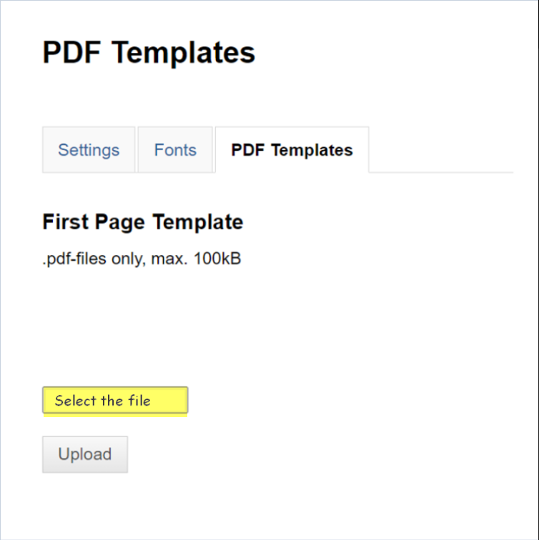
2. Select the file and click on the Open button
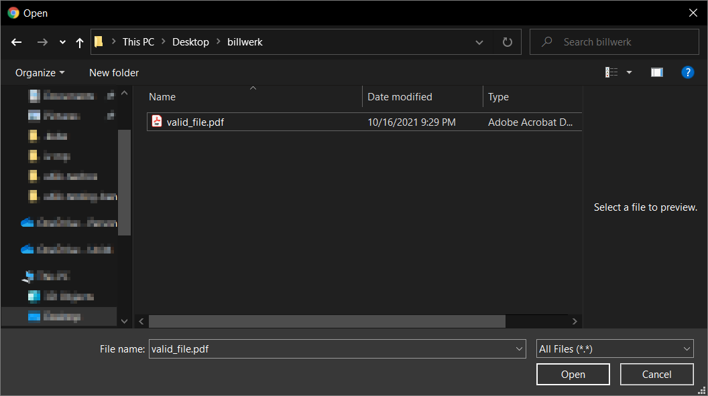
3. Verify that the correct file name is presented on the PDF Templates tab
4. Click on the Upload button
Test Case ID: 002
Description:
Upload button is active only after the file has been selected
Pre-Conditions:
Open app, log in and navigate to PDF Templates and select the PDF Templates tab
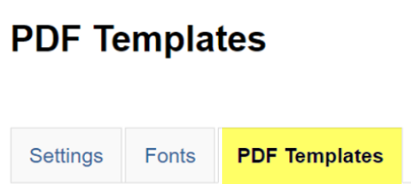
Steps:
1. Click on the Upload button
2. Verify that button is disabled and no action takes place
Post-Conditions:
1. Button is disabled
Test Case ID: 003
Description:
File is not selected when open file action is cancelled
Pre-Conditions:
Open app, log in and navigate to PDF Templates and select the PDF Templates tab
Steps:
1. Click on the Select the file button
2. Select the file and click on the cancel button
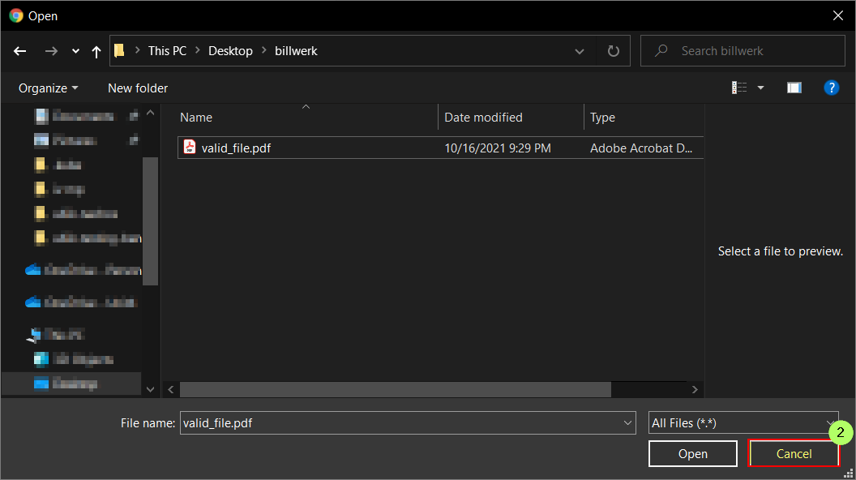
Post-Conditions:
1. File was not selected – Select the file field is empty

